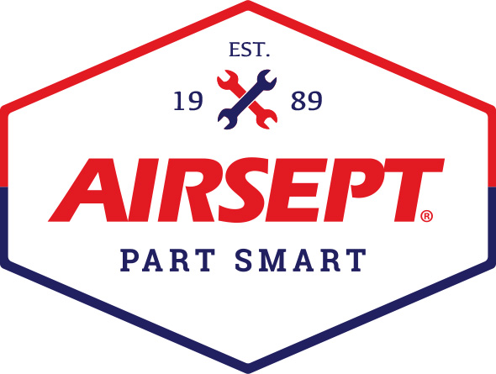

News Release

AirSept Announces New Hire for Vice President, Sales & Marketing –
Service Tool, Equipment & Chemical Executive, Chuck Abbott

Atlanta – March 10, 2022 – AirSept, a leader in developing innovative solutions for the repair industry and manufacturer of the award-winning Smart Splice™ line connectors, A/C and HVAC service tools and indoor air quality chemicals, announces the addition of Charles “Chuck” Abbott as the company’s new vice president of sales & marketing.

Hired March 1 by Aaron Becker, AirSept’s president, Abbott’s expertise is in transforming businesses for profitable growth in the tool, equipment and chemical categories via multiple channels to the automotive and HVAC/R service markets.

Abbott previously served as Vice President, Global Automotive Sales for CPS Products, Inc. There, Abbott managed strategic accounts including Snap-on and Lockheed Martin and was the primary architect of a sales team that significantly grew sales with a focus on new, innovative products, leveraging private label programs, improving customer retention, and expanding distribution here and abroad.

AirSept President Aaron Becker, says, “Rarely do you find a candidate whose professional background and thought processes are so closely aligned to your company’s products and marketing needs. Chuck has a remarkable history of building brands for our specialized industry in addition to having long-standing excellent relationships with product managers with major automotive retailers, the mobility market, suppliers and manufacturer representatives. AirSept is poised for major growth with our inventory of over 20 award-winning professional service tools that saves time and money, which is especially relevant now with vehicles staying in service longer. I feel confident that Chuck, with his insight to our industry, his penchant for successful strategic planning, and new business development is the right person to capitalize on our strengths and develop a plan to catapult sales.”

Currently Abbott serves on the board of directors for the Automotive Maintenance & Repair Association and previously served on the board of directors for the Equipment Tool Institute. Abbott, a graduate of Lesley University, will have a hybrid work schedule working primarily from his home in Indianapolis.

For more information about AirSept’s award winning professional tools and equipment, or the latest company news, visit www.airsept.com. call 800.999.1051, or email information@airsept.com. To reach Chuck Abbott direct, email cabbott@airsept.com.
# # # #

Image Attached:

About AirSept
In 1989 AirSept created the first long-lasting solution to the problem of unwanted mold and mildew odor in automobile air conditioning systems. The product quickly became popular and in 1991 AirSept was incorporated as a company. AirSept began partnering with global OEMs and suppliers to not only market its Cooling Coil Coating, but to also develop other unique, new problem-solving products. From those humble beginnings, AirSept has grown to be the industry leader in the development of OEM and aftermarket solutions to complex repair problems. AirSept products are designed to save time, money and labor. For more information, visit AirSept.com.

For further product information, contact:
Aaron Becker, President
AirSept
678-973-2287
abecker@airsept.com

Leslie Allen
Owner
Wildcat Communications
615-429-7965
leslieallen.wildcat@gmail.com

